How to input WIFI credential

* Plug the device to power using the usb cable.
* The device will create a AP name SetupGadget_XXXXX. Connect your computer/phone to it.

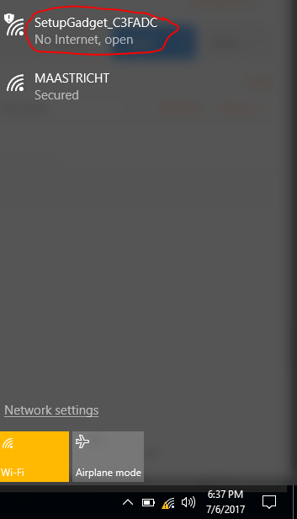

* Open any browser on your connected device and communicate with the device via this IP address (192.168.4.1). Then scan for available APs.

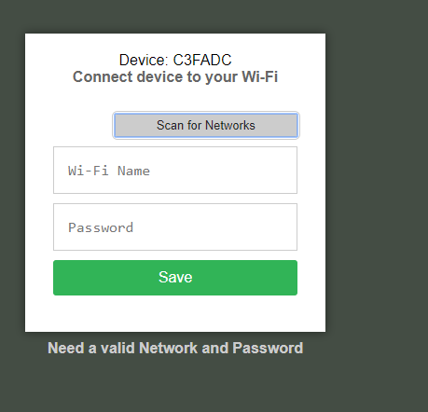

* Select from the list, input the password to the AP and click **save**

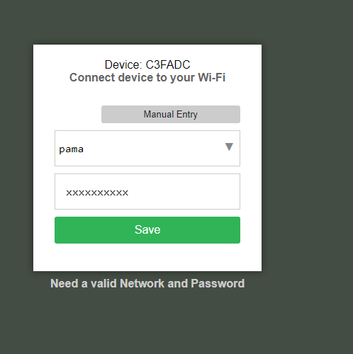

* You will get a screen like this

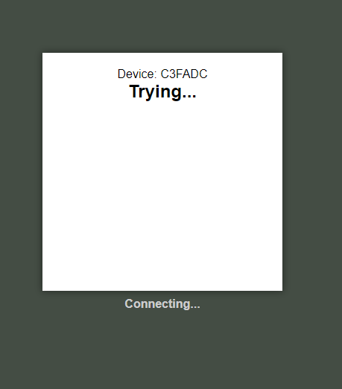

* After a successful connection, you will get a success message.

